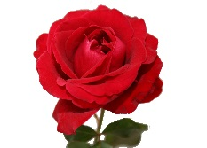
The British Folktale of Briar Rose

Vocabulary Words:
briar | contain | feast | gracious | splendidly
celebrated | virtue | avenge | wound | spindle
plucked | sensible | chambers | flax | astonishment
prick | courtiers | hearth | flickering | sputtering
surrounded | hedge | perished | accord | perched

Fill in the blanks with the correct words from the list above.

1. The briars _______________ the castle.
2. The king was hopeful that his guests might be ______________ and kind to his child.
3. He had a great _______________ to welcome his guests.
4. The king and queen could not _______________ their great joy at the birth of their daughter.
5. The tables were laid _______________ with great amounts of food.
6. The light from the candles was ______________ in and out.
7. Briar Rose found the ______________ in the tower.
8. The wise woman who was not invited to the feast wanted to _______________ herself with a curse on the Briar Rose.
9. Over one hundred years passed and the _______________ grew very high around the castle.
10. When the prince and Briar Rose married they all _______________ together.

